Unit 9 – Lesson 2. N – gram Word Indicator Algorithm and Introduction to R

Aim: What is N-Gram?

Objectives: After the lesson, students should be able to:
- Obtain understanding of N-gram

References:
- Stanford University, N-Grams and SLP
https://web.stanford.edu/class/cs124/lec/languagemodeling.pdf

CLASS PROCEDURE:
Do Now: What is an N-gram word predictor?
https://arttu.shinyapps.io/word_predictor/

Recall the Ngram we discussed last week.
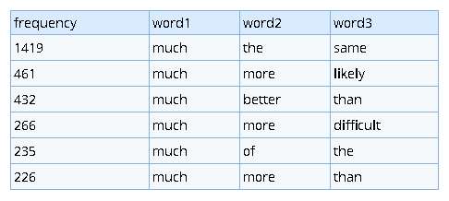
Source: https://www.ngrams.info/

How to compute this joint probability:
P(its, water, is, so, transparent, that)
Class Discussion / Presentation:
- What is the definition of conditional probability?
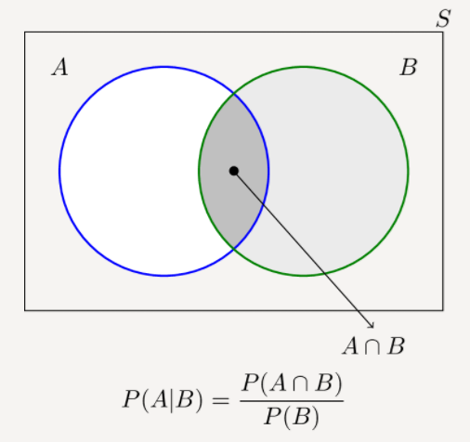
- If we have more variables, how do we derive
P(A, B, C, D) = P(A) P(B|A) P(C|A, B) P(D| A, B, C)
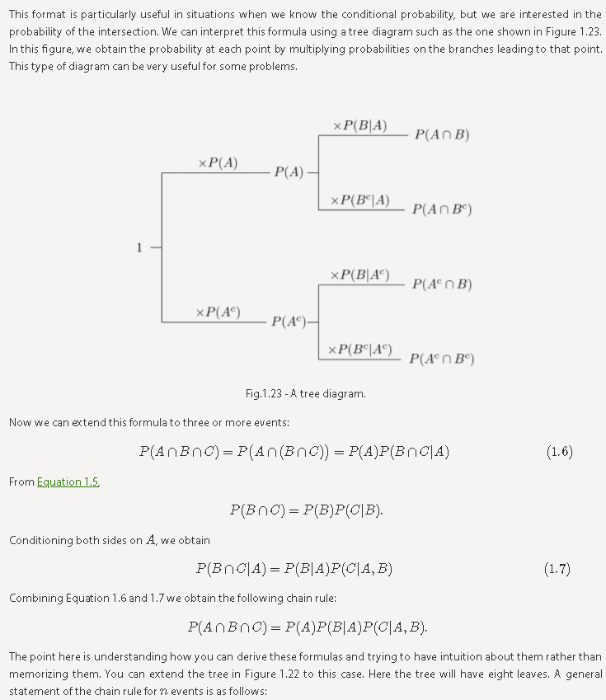

Source: https://www.probabilitycourse.com/chapter1/1_4_0_conditional_probability.php

- What is the chain rule in conditional probability?
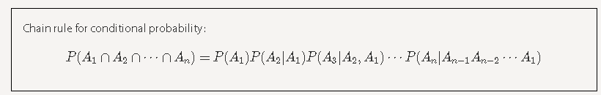
P(X1, X2, X3, X4, …., Xn) = ________________________________________________
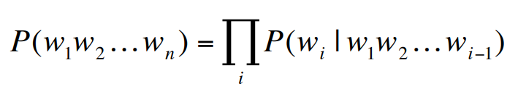

- The answer to the “Do Now” question:

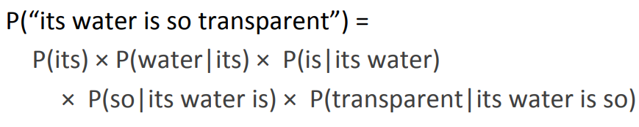

- Could we just count and divide? Why?

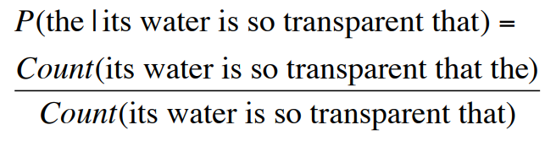

The question: Will we have enough data for estimating these?

- Markov assumption to simplify the assumption:

Or:

- Markov Assumption:

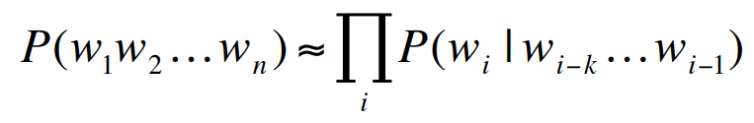
Or:

Pair – sharing Practice:

To fully understand the Ngram NLP model, for our next project we will use R to build a word predictor with Ngram. You can explore the sample work build by someone else here https://arttu.shinyapps.io/word_predictor/

Use https://campus.datacamp.com/courses/free-introduction-to-r/chapter-1-intro-to-basics-1?ex=1 to get familiar with the syntax of R.

If you are already familiar with R, read the PPT provided by this lesson and start to build the project.

Due: April 9th. Presentation in class.

